**Batch: C3 Roll No.: 16010123217**

**Experiment / assignment / tutorial No. 1**

|  |
| --- |
| **TITLE:** Study of PCI and SCSI. |

**AIM: To Study and learn PCI and SCSI**

**______________________________________________________________________**

**Expected OUTCOME of Experiment : (Mention CO/CO’s attained here )**

**______________________________________________________________________Books/ Journals/ Websites referred:**

1. [**https://www.techopedia.com/definition/8815/peripheral-component-interconnect-bus-pci-bus**](https://www.techopedia.com/definition/8815/peripheral-component-interconnect-bus-pci-bus)
2. [**https://www.techopedia.com/definition/331/small-computer-system-interface-scsi**](https://www.techopedia.com/definition/331/small-computer-system-interface-scsi)
3. [**http://www.csun.edu/~edaasic/roosta/BUS_Structures.pdf**](http://www.csun.edu/~edaasic/roosta/BUS_Structures.pdf)
4. W.Stallings William “Computer Organization and Architecture: Designing for Performance”, Pearson Prentice Hall Publication, 7thEdition. C.

**Pre Lab/ Prior Concepts:**

Microcomputer buses which communicate with a peripheral devices or a memory location through communication lines called buses.

The major parts of microcomputers are central processing unit (CPU), memory, and input and output unit. To connect these parts together through three sets of parallel lines, called buses.  These three buses are  Address bus, data bus, and Control bus.

**Address Bus:**

The address bus consists of 16, 20, 24, or more parallel signal lines, through which the CPU sends out the address of the memory location. This memory location is used for to written to or read from. The number of memory location is depends on 2 to the power N address lines.  Example, a CPU with 16 address lines can address 216 or 65,536 memory locations. When the CPU reads data from or writes data to a port. The port address is also sent out on the address bus. This is unidirectional. This means that the CPU can send data to a memory location or I/O ports.

**Data Bus:**

The data bus consists of 8, 16, 32 or more parallel signal lines. The data bus lines are bidirectional. This means that the CPU can read data from memory or from a I/O port as well as send data to a memory location or to a I/O port. In a system, many output devices are connected to the data bus, but only one device at a time will be enabled to the output.

**Control Bus:**

The control bus consists of 4-10 parallel signal lines. The CPU sends out signals on the control bus to enable the outputs of addressed memory devices or port devices. Typically control bus signals are memory read, memory write, I/O read and I/O write. To read a data from a memory location, the CPU sends out the address of the desired data on the address bus and then sends out a memory read signal on the control bus. The memory read signal enables the addressed memory device to output the data onto the data bus where it is read by the CPU.

**PCI Bus**

**Ans .** PCI stands for Peripheral Component Interconnect.

**Features of PCI Bus:**

* High-speed Data Transfer: PCI can move data way faster compared to older systems like ISA.
* Multiple Device Support : You can connect several peripheral devices to just one bus. Each device gets its own address space, which is neat.
* Plug-and-Play compatibility: With PCI, you can add or remove devices without restarting your compute if your operating system supports.
* Bus mastering: This means that devices can take control of the bus for data transfer without CPU intervention, enhancing efficiency.

### ****Pin Diagram of PCI Bus:****

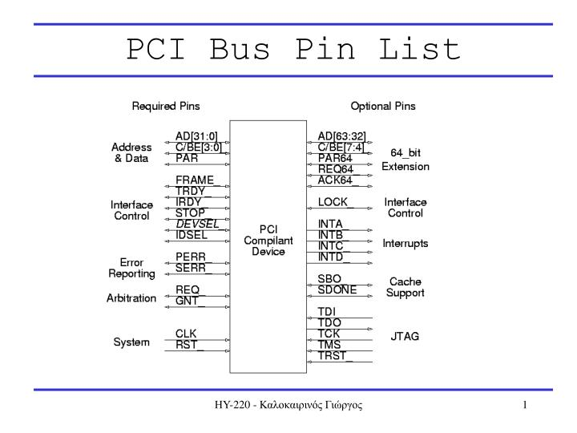

**Architecture of PCI Bus:**

* The PCI bus uses a shared setup, meaning devices share a common pathway (the bus) for moving data around.
* Every PCI device has its own configuration registers to control things and set them up. The PCI controller manages this part.
* This bus design helps the CPU comminicate efficiently with peripheral devices through direct memory access (DMA) and interrupts.

**Versions of PCI Bus:**

* PCI: This is the first standard that runs at 33 MHz with a 32-bit data path.
* PCI-X: It’s an enhanced version that goes faster (up to 133 MHz) and has wider data paths (64-bit and 133 MHz).
* PCI Express (PCIe): This is the current standard. It features scalable bandwidth options (1x, 2x, 4x, 8x, 16x, 32x) and improved data transfer rates (up to several GB/s per lane).

**Advantages of PCI Bus:**

* **Faster Data Transfer:** Compared to older standards, PCI offers higher bandwidth and faster speeds.
* **Scalability:** With PCI-X & PCIe, provide scalable options for all kinds of performance needs.
* **Backward Compatibility:** We can still use those old PCI devices on newer systems.

**Disadvantages of PCI Bus:**

* **Shared Bus Limitation:** As devices on same PCI bus must share bandwidth, this might lead to performance issues.
* **Limited Bandwidth:** Older PCI standards may not meet the bandwidth requirements of modern high-performance devices.
* **Complexity:** It can get complicated by managing multiple devices on a shared bus, especially for larger systems.

The PCI bus has changed a lot since it first showed up. It's adjusted to meet the growing needs of modern computing but still works well with older hardware.

**SCSI bus:**

### Features of SCSI Bus:

* **High-Speed Data Transfer:** SCSI offers high-speed data transfer rates suitable for servers & high-performance computing needs.
* **Multiple Device Support:** You can connect lots of devices (up to 15 or more depending on the SCSI variant) They can be daisy-chained or set up in a bus layout.
* **Wide Device Compatibility:** It works with many devices like hard drives, tape drives, scanners, printers, & many others.
* **Flexible Configuration:** We can swap devices while the system’s running. Plus, each device gets a unique ID to keep things organized on the bus.

**Pin diagram of SCSI Bus:**

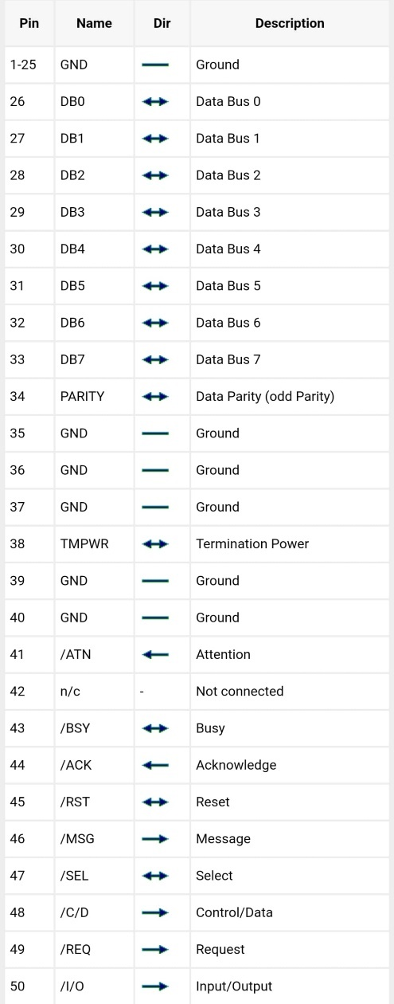

### Architecture of SCSI Bus:

* **Bus Arbitration:** SCSI devices use a priority-based arbitration scheme to determine which device can access the bus at any given time.
* **Command Set:** SCSI uses a standardized command set for device communication, allowing for consistent data transfer protocols across different devices.
* **Termination:** It’s super important to have proper bus termination in SCSI setups. That way, you avoid problems from signal reflections & keep data safe.

### Versions of SCSI Bus:

* **SCSI-1:** Original standard with 8-bit data path and speeds up to 5 MB/s.
* **SCSI-2:** Improved with 8-bit and 16-bit data paths, faster speeds, and enhanced command set.
* **SCSI-3:** Brought us Wide SCSI & Ultra SCSI variants which are even faster. Plus, they added neat features like packetized data transfer.
* **SCSI-U320 and beyond:** Ultra320 SCSI and later versions saw even faster speeds. They also introduced LVD (Low Voltage Differential) for stronger signal integrity.

### Advantages of SCSI Bus:

* **High Performance:** SCSI's got high data transfer rates keeping CPU overhead low. This makes it great for demanding applications.
* **Scalability:** It can handle lots of devices all in one chain or bus. That’s perfect for complicated storage setups.
* **Reliability:** Its strong protocol & termination practices ensure reliable data transmission.

**Disadvantages of SCSI Bus:**

* **Cost:** SCSI peripherals and controllers usually costs more than other interfaces such as SATA or SAS.
* **Complexity:** Configuring and managing SCSI devices, especially in large installations, can be more complex compared to plug-and-play interfaces.
* **Limited Host Support**: Not all consumer devices support SCSI as much as they do for other interfaces. This can make compatibility an issue in certain situations.

SCSI is still a solid option for high-performance computing & storage needs where reliability & speed are super important despite newer interfaces like SATA and SAS gaining popularity in mainstream computing.

**Post Lab Descriptive Questions**

**Q1 . Differentiate between PCI and SCSI Bus**

### Difference Between SCSI and PCI:

|  |  |  |
| --- | --- | --- |
| Characteristic | PCI | SCSI |
| Bus Type | Backplane | I/O |
| Data bus width | 32-64 | 8-32 |
| Arbitration | Centralized parallel | Self-selection |
| Clocking | Synch 33-66 MHz | Asynch & Synch 5-10 MHz |
| Max Bandwidth | 133-512 MB/Sec | 5-40 MB/Sec |
| Typical Bandwidth | 80 MB/Sec | 2.5-40 MB/Sec Synch  1.5 MB/Sec Asynch |
| Max Devices | 1024 | 7-31 |
| Max Bus Length | 0.5 meters | 2.5 meters |

**Q2. List two applications each of PCI and SCSI Bus**

**Ans.**

### Applications of PCI Bus:

**Graphics Cards:** PCI (Peripheral Component Interconnect) buses are super common for linking graphics cards to a computer's motherboard. These cards need fast data transfer rates, which PCI buses provide, helping images & videos render smoothly.

**Network Interface Cards (NICs):** Another typical use for PCI buses is in network interface cards. These cards connect computers to networks, & the high bandwidth from PCI lets data flow efficiently over the network.

### Applications of SCSI Bus:

**Hard Disk Drives:** SCSI (Small Computer System Interface) buses are often found in servers and powerful workstations to connect hard disk drives. SCSI's ability to support several devices & provide rapid data transfer rates makes it suitable for applications that need lots of data.

**Scanners and Printers:** SCSI also connects peripherals like scanners & printers to computers. It has strong performance and can handle many devices, which makes it a great fit for these peripherals, especially in professional or industrial settings.

**Date: 19/7/24**

**Batch: Roll No.:**

**Experiment / assignment / tutorial No._______**

|  |
| --- |
| **TITLE:** To study and implement Booth’s Multiplication Algorithm. |

**AIM:** Booth’s Algorithm for Multiplication

**______________________________________________________________________**

**Expected OUTCOME of Experiment: (Mention CO/CO’s attained here)**

**_____________________________________________________________________**

**Books/ Journals/ Websites referred:**

1. Carl Hamacher, Zvonko Vranesic and Safwat Zaky, “Computer Organization”, Fifth Edition, TataMcGraw-Hill.
2. William Stallings, “Computer Organization and Architecture: Designing for Performance”, Eighth Edition, Pearson.

3. Dr. M. Usha, T. S. Srikanth, “Computer System Architecture and Organization”, First Edition, Wiley-India.

**_____________________________________________________________________**

**Pre Lab/ Prior Concepts:**

It is a powerful algorithm for signed number multiplication which generates a 2n bit product and treats both positive and negative numbers uniformly. Also the efficiency of the algorithm is good due to the fact that, block of 1’s and 0’s are skipped over and subtraction/addition is only done if pair contains 10 or 01

**Flowchart:**

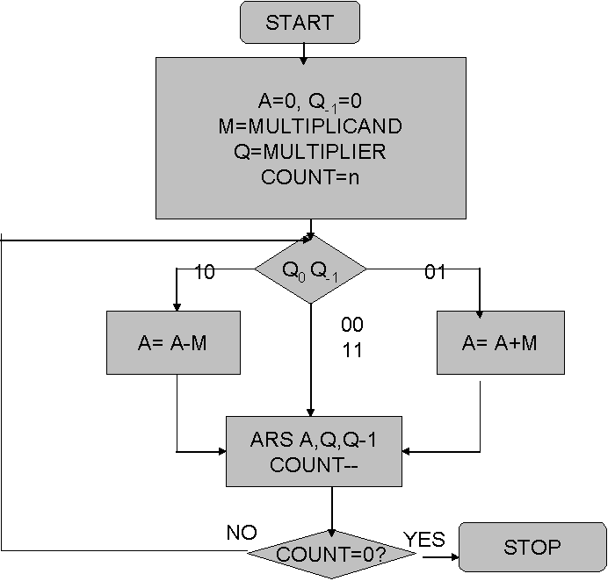

**Design Steps**:

1. Start
2. Get the multiplicand (M) and Multiplier (Q) from the user
3. Initialize A= Q-1 =0
4. Convert M and Q into binary
5. Compare Q0 andQ-1 and perform the respective operation.

|  |  |
| --- | --- |
| **Q0 Q-1** | **Operation** |
| 00/11 | Arithmetic right shift |
| 01 | A+M and Arithmetic right shift |
| 10 | A-M and Arithmetic right shift |

6. Repeat steps 5 till all bits are compared

7. Convert the result to decimal form and display

8. End

Example: (Handwritten solved problem needs to be uploaded)

**Conclusion:**

**Post Lab Descriptive Questions**

1. **Explain advantages and disadvantages of Booth’s algorithm.**
2. **Is Booth’s recoding better than Booth’s algorithm? Justify**

**Date: _____________**

**Batch: Roll No.:**

**Experiment / assignment / tutorial No._______**

|  |
| --- |
| **TITLE :** To study and implement Restoring method of division |

**AIM :** The basis of algorithm is based on paper and pencil approach and the operation involves repetitive shifting with addition and subtraction. So the main aim is to depict the usual process in the form of an algorithm.

**______________________________________________________________________**

**Expected OUTCOME of Experiment: (Mention CO /CO’s attained here)**

**_____________________________________________________________________**

**Books/ Journals/ Websites referred:**

1. Carl Hamacher, Zvonko Vranesic and Safwat Zaky, “Computer Organization”, Fifth Edition, TataMcGraw-Hill.
2. William Stallings, “Computer Organization and Architecture: Designing for Performance”, Eighth Edition, Pearson.

**3**. Dr. M. Usha, T. S. Srikanth, “Computer System Architecture and Organization”, First Edition, Wiley-India.

**_____________________________________________________________________**

**Pre Lab/ Prior Concepts:**

The Restoring algorithm works with any combination of positive and negative numbers

**Flowchart for Restoring of Division:**

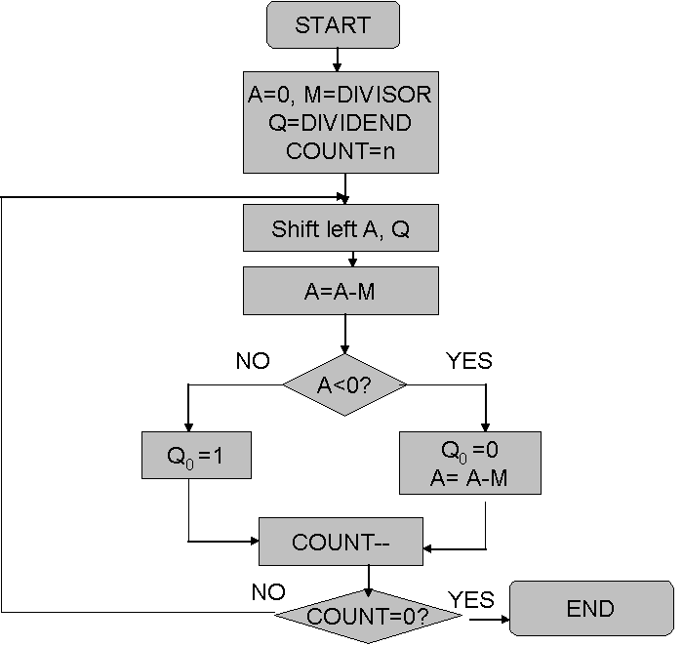

**Design Steps**:

1. Start
2. Initialize A=0, M=Divisor, Q=Dividend and count=n (no of bits)
3. Left shift A, Q
4. If MSB of A and M are same
5. Then A=A-M
6. Else A=A+M
7. If MSB of previous A and present A are same
8. Q0=0 & store present A
9. Else Q0=0 & restore previous A
10. Decrement count.
11. If count=0 go to 11
12. Else go to 3
13. STOP

**Example:- (Handwritten solved problems needs to be uploaded)**

**Conclusion**

**Post Lab Descriptive Questions**

1. **What are the advantages of restoring division over non restoring division?**

**Date: _____________**

**Batch: Roll No.:**

**Experiment / assignment / tutorial No._______**

|  |
| --- |
| **TITLE :** To study and implement Non Restoring method of division |

**AIM :** The basis of algorithm is based on paper and pencil approach and the operation involve repetitive shifting with addition and subtraction. So the main aim is to depict the usual process in the form of an algorithm.

**______________________________________________________________________**

**Expected OUTCOME of Experiment: (Mention CO/CO’s attained here)**

**_____________________________________**

**Books/ Journals/ Websites referred:**

1. Carl Hamacher, Zvonko Vranesic and Safwat Zaky, “Computer Organization”, Fifth Edition, TataMcGraw-Hill.
2. William Stallings, “Computer Organization and Architecture: Designing for Performance”, Eighth Edition, Pearson.

**3**. Dr. M. Usha, T. S. Srikanth, “Computer System Architecture and Organization”, First Edition, Wiley-India.

**_____________________________________________________________________**

**Pre Lab/ Prior Concepts:**

The Non Restoring algorithm works with any combination of positive and negative numbers.

**Flowchart for Non Restoring of Division( Students need to draw)**

**Example: (Handwritten solved problem needs to uploaded)**

**Conclusion**

**Post Lab Descriptive Questions**

**What are the advantages of non restoring division over restoring division?**

**Date: _____________**

**Batch: Roll No.:**

**Experiment / assignment / tutorial No._______**

|  |
| --- |
| **TITLE: Implementation of IEEE-754 floating point representation** |

**AIM:** To demonstrate the single and double precision formats to represent floating point numbers.

**______________________________________________________________________**

**Expected OUTCOME of Experiment: (Mention CO attained here)**

**___________________________________________________________________**

**Books/ Journals/ Websites referred:**

1. Carl Hamacher, Zvonko Vranesic and Safwat Zaky, “Computer Organization”, Fifth Edition, TataMcGraw-Hill.
2. William Stallings, “Computer Organization and Architecture: Designing for Performance”, Eighth Edition, Pearson.

**_____________________________________________________________________**

**Pre Lab/ Prior Concepts:**

The IEEE Standard for Floating-Point Arithmetic (IEEE 754) is a [technical standard](https://en.wikipedia.org/wiki/Technical_standard) for [floating-point](https://en.wikipedia.org/wiki/Floating_point) computation established in 1985 by the [Institute of Electrical and Electronics Engineers](https://en.wikipedia.org/wiki/Institute_of_Electrical_and_Electronics_Engineers) (IEEE). The standard [addressed many problems](https://en.wikipedia.org/wiki/Floating_point#IEEE_754_design_rationale) found in the diverse floating point implementations that made them difficult to use reliably and [portably](https://en.wikipedia.org/wiki/Software_portability). Many hardware [floating point units](https://en.wikipedia.org/wiki/Floating_point_unit) now use the IEEE 754 standard.

The standard defines:

* *arithmetic formats:* sets of [binary](https://en.wikipedia.org/wiki/Binary_code) and [decimal](https://en.wikipedia.org/wiki/Decimal) floating-point data, which consist of finite numbers (including [signed zeros](https://en.wikipedia.org/wiki/Signed_zero) and [subnormal numbers](https://en.wikipedia.org/wiki/Subnormal_number)), [infinities](https://en.wikipedia.org/wiki/Infinity), and special "not a number" values ([NaNs](https://en.wikipedia.org/wiki/NaN))
* *interchange formats:* encodings (bit strings) that may be used to exchange floating-point data in an efficient and compact form
* *rounding rules:* properties to be satisfied when rounding numbers during arithmetic and conversions
* *operations:* arithmetic and other operations (such as [trigonometric functions](https://en.wikipedia.org/wiki/Trigonometric_functions)) on arithmetic formats
* *exception handling:* indications of exceptional conditions (such as [division by zero](https://en.wikipedia.org/wiki/Division_by_zero), overflow, *etc*

**Example (Single Precision- 32 bit representation )**

**Example (Double Precision- 64 bit representation )**

**Post Lab Descriptive Questions**

**Give the importance of IEEE-754 representation for floating point numbers?**

**Conclusion**

**Date: _____________**

**Batch: Roll No.:**

**Experiment / assignment / tutorial No._______**

|  |
| --- |
| **TITLE: Implementation of LRU Page Replacement Algorithm.** |

**AIM:** The LRU algorithm replaces the least recently used that is the last accessed memory block from user.

**______________________________________________________________________**

**Expected OUTCOME of Experiment: (Mention CO/CO’s attained here)**

**___________________________________________________________________**

**Books/ Journals/ Websites referred:**

1. Carl Hamacher, Zvonko Vranesic and Safwat Zaky, “Computer Organization”, Fifth Edition, TataMcGraw-Hill.
2. William Stallings, “Computer Organization and Architecture: Designing for Performance”, Eighth Edition, Pearson.

**_____________________________________________________________________**

**Pre Lab/ Prior Concepts:**

It follows a simple logic, while replacing it will replace that page which has least recently used out of all.

a) A hit is said to be occurred when a memory location requested is already in the cache.

b) When cache is not full, the number of blocks is added.

c) When cache is full, the block is replaced which is recently used

**Algorithm:**

1. Start
2. Get input as memory block to be added to cache
3. Consider an element of the array
4. If cache is not full, add element to the cache array
5. If cache is full, check if element is already present
6. If it is hit is incremented
7. If not, element is added to cache removing least recently used element
8. Repeat step 3 to 7 for remaining elements
9. Display the cache at very instance of step 8
10. Print hit ratio
11. End

**Example:**

**Post Lab Descriptive Questions**

**1. Define hit rate and miss ratio?**

**2. What is the need for virtual memory**?

**Conclusion**

**Date: _____________**

**Batch: Roll No.:**

**Experiment / assignment / tutorial No._______**

|  |
| --- |
| **TITLE :**Implementation ofFIFO Page Replacement Algorithm |

**AIM:** The FIFO algorithm uses the principle that the block in the set which has been in for the longest time will be replaced

**______________________________________________________________________**

**Expected OUTCOME of Experiment: (Mention CO/CO’s attained here)**

**_____________________________________________________________________**

**Books/ Journals/ Websites referred:**

1. Carl Hamacher, Zvonko Vranesic and Safwat Zaky, “Computer Organization”, Fifth Edition, TataMcGraw-Hill.
2. William Stallings, “Computer Organization and Architecture: Designing for Performance”, Eighth Edition, Pearson.

**3**. Dr. M. Usha, T. S. Srikanth, “Computer System Architecture and Organization”, First Edition, Wiley-India.

**---------------------------------------------------------------------------------------------------------**

**Pre Lab/ Prior Concepts:**

T he FIFO algorithm uses the principle that the block in the set which has been in the block for the longest time is replaced. FIFO is easily implemented as a round robin or criteria buffer technique. The data structure used for implementation is a queue. Assume that the number of cache pages is three. Let the request to this cache is shown alongside.

**Algorithm:**

1. A hit is said to be occurred when a memory location requested is already in the cache.

2. When cache is not full, the number of blocks is added.

3. When cache is full, the block is replaced which was added first

**Design Steps:**

1. Start
2. Get input as memory block to be added to cache
3. Consider an element of the array
4. If cache is not full, add element to the cache array
5. If cache is full, check if element is already present
6. If it is hit is incremented
7. If not, element is added to cache removing first element (which is in first).
8. Repeat step 3 to 7 for remaining elements
9. Display the cache at very instance of step 8
10. Print hit ratio
11. End.

**Example:**

**Post Lab Descriptive Questions**

**1. What is meant by memory interleaving?**

**2. Explain Paging Concept?**

**Conclusion**

**Date: _____________**

**Batch: Roll No.:**

**Experiment / assignment / tutorial No._______**

|  |
| --- |
| **TITLE :** Implementation of Cache Mapping Techniques. |

**AIM:** To study and implement concept of various mapping techniques designed for cache memory.

**______________________________________________________________________**

**Expected OUTCOME of Experiment: (Mention CO/CO’s attained here)**

**_____________________________________________________________________**

**Books/ Journals/ Websites referred:**

1. Carl Hamacher, Zvonko Vranesic and Safwat Zaky, “Computer Organization”, Fifth Edition, TataMcGraw-Hill.
2. Dr. M. Usha, T. S. Srikanth, “Computer System Architecture and Organization”, First Edition, Wiley-India.

**___________________________________________________________**

**Pre Lab/ Prior Concepts:**

Cache memory: The cache is a smaller, faster memory which stores copies of the data from the most frequently used main memory locations. As long as most memory accesses are cached memory locations, the average latency of memory accesses will be closer to the cache latency than to the latency of main memory.

2. Hit Ratio: You want to increase as much as possible the likelihood of the cache containing the memory addresses that the processor wants.

**Hit Ratio= No. of hits/ (No. of hits + No. of misses)**

There are only fewer cache lines than the main memory blocks, an algorithm is needed for mapping main memory blocks into cache lines. Further a means is needed for determining which main memory block currently occupies in a cache line. The choice of cache function dictates how the cache is organized. Three techniques can be used.

1. Direct mapping.
2. Associative mapping.
3. Set Associative mapping.

**Direct Mapped Cache**: The direct mapped cache is the simplest form of cache and the easiest to check for a hit. Since there is only one possible place that any memory location can be cached, there is nothing to search; the line either contains the memory information we are looking for, or it doesn't.  
Unfortunately, the direct mapped cache also has the worst performance, because again there is only one place that any address can be stored. Let's look again at our 512 KB level 2 cache and 64 MB of system memory. As you recall this cache has 16,384 lines (assuming 32-byte cache lines) and so each one is shared by 4,096 memory addresses. In the absolute worst case, imagine that the processor needs 2 different addresses (call them X and Y) that both map to the same cache line, in alternating sequence (X, Y, X, Y). This could happen in a small loop if you were unlucky. The processor will load X from memory and store it in cache. Then it will look in the cache for Y, but Y uses the same cache line as X, so it won't be there. So Y is loaded from memory, and stored in the cache for future use. But then the processor requests X, and looks in the cache only to find Y. This conflict repeats over and over. The net result is that the hit ratio here is 0%. This is a worst case scenario, but in general the performance is worst for this type of mapping.

**Fully Associative Cache:** The fully associative cache has the best hit ratio because any line in the cache can hold any address that needs to be cached. This means the problem seen in the direct mapped cache disappears, because there is no dedicated single line that an address must use.However (you knew it was coming), this cache suffers from problems involving searching the cache. If a given address can be stored in any of 16,384 lines, how do you know where it is? Even with specialized hardware to do the searching, a performance penalty is incurred. And this penalty occurs for all accesses to memory, whether a cache hit occurs or not, because it is part of searching the cache to determine a hit. In addition, more logic must be added to determine which of the various lines to use when a new entry must be added (usually some form of a "least recently used" algorithm is employed to decide which cache line to use next). All this overhead adds cost, complexity and execution time.

**Set Associative Cache (To be filled in by students)**

**Direct Mapping Implementation:**

The mapping is expressed as

**i=j modulo m**

i=cache line number

j= main memory block number

m= number of lines in the cache

* Address length = (s+w) bits
* Number of addressable units = 2s+w words or bytes
* Block size = line size = 2w words or bytes
* Number of blocks in main memory = 2s+w / 2w = 2s
* Number of lines in cache = m = 2r
* Size of tag = (s-r) tags

**Associative Mapping Implementation**: **(To be filled in by students)**

**Set** **Associative Mapping Implementation**:

**Post Lab Descriptive Questions**

**1. For a direct mapped cache, a main memory is viewed as consisting of 3 fields. List and define 3 fields.**

**2. What is the general relationship among access time, memory cost, and capacity?**

**Conclusion**

**Date: _____________**

**Batch: Roll No.:**

**Experiment / assignment / tutorial No._______**

|  |
| --- |
| **TITLE:** Study of RISC and CISC Architecture |

**AIM:** Understanding RISC and CISC Architecture

**_______________________________________________________________**

**Expected OUTCOME of Experiment: (Mentions the CO/CO’s attained)**

**__________________________________________________________________**

**Books/ Journals/ Websites referred:**

1. Carl Hamacher, Zvonko Vranesic and Safwat Zaky, “Computer Organization”, Fifth Edition, TataMcGraw-Hill.
2. William Stallings, “Computer Organization and Architecture: Designing for Performance”, Eighth Edition, Pearson.

**3**. Dr. M. Usha, T. S. Srikanth, “Computer System Architecture and Organization”, First Edition, Wiley-India.

**_____________________________________________________________________**

**Pre Lab/ Prior Concepts:**

**Reduced Set Instruction Set Architecture (RISC)**The main idea behind is to make hardware simpler by using an instruction set composed of a few basic steps for loading, evaluating and storing operations just like a load command will load data, store command will store the data.

**Complex Instruction Set Architecture (CISC**)   
The main idea is that a single instruction will do all loading, evaluating and storing operations just like a multiplication command will do stuff like loading data, evaluating and storing it, hence it’s complex.Both approaches try to increase the CPU performance

**RISC Architecture**

1. Diagram of RISC Architecture:
2. Brief Explanation of each component
3. RISC Processor Instruction Set Examples with explanation (Any 2)

**CISC Architecture**

1. Diagram of CISC Architecture:
2. Brief Explanation of each component
3. CISC Processor Instruction Set Examples with explanation (Any 2)

**Post Lab Descriptive Questions**

**Write a tabular comparative analysis of RISC v/s CISC**

**Conclusion:**

**Date: _____________ Signature of faculty in-charge**

**Batch: Roll No.:**

**Experiment / assignment / tutorial No._______**

|  |
| --- |
| **TITLE:** Study of multiprocessor configuration concepts through Virtual lab |

**AIM:** Understanding Virtual Lab concepts

**_______________________________________________________________**

**Expected OUTCOME of Experiment:**

**__________________________________________________________________**

**Books/ Journals/ Websites referred:**

<http://vlabs.iitb.ac.in/vlab/labscse.html>

[http://vlabs.iitb.ac.in/vlab/#](http://vlabs.iitb.ac.in/vlab/)

<http://www.vlab.co.in/>

**_____________________________________________________________________**

**Pre Lab/ Prior Concepts:**

The main aim of this experiment is to provide remote-access to Labs in various disciplines of Science and Engineering. These Virtual Labs would cater to students at the undergraduate level, post graduate level as well as to research scholars. Also, to enthuse students to conduct experiments by arousing their curiosity. This would help them in learning basic and advanced concepts through remote experimentation. It also provides a complete Learning Management System around the Virtual Labs where the students can avail the various tools for learning, including additional web-resources, video-lectures, animated demonstrations and self-evaluation. We can share costly equipment and resources, which are otherwise available to limited number of users due to constraints on time and geographical distances

**Salient Features:**

. 1. Virtual Labs will provide to the students the result of an experiment by one of the following methods (or possibly a combination)

* Modeling the physical phenomenon by a set of equations and carrying out simulations to yield the result of the particular experiment. This can, at-the-best, provide an approximate version of the ‘real-world’ experiment.
* Providing measured data for virtual lab experiments corresponding to the data previously obtained by measurements on an actual system.
* Remotely triggering an experiment in an actual lab and providing the student the result of the experiment through the computer interface. This would entail carrying out the actual lab experiment remotely.

2. Virtual Labs will be made more effective and realistic by providing additional inputs to the students like accompanying audio and video streaming of an actual lab experiment and equipment.

**Observations**

**Title of Study Experiment:**

**Brief description of experiment under study**

**Learning’s recorded:**

**Knowledge gained / Inference Obtained :**

**Post Lab Descriptive Questions**

**1. What are the applications of the virtual lab case study / tool reviewed by you?**

**Conclusion**